Continual Assessment (2025)
Data Analytics CA Report
Philip Filippenko
Abstract
In this study, the report will explore the trend of game performances within the PlayStation platform and assess the robustness of the companies’ publishing games on the PS3, PS4, and PS5 console generations. The aim of the study is to determine if sequels improve or decline when new console generations are developed, and which companies are producing robust and stable performances. Data used to complete the analysis is found within the PlayStationSales.csv file.
The study adopts the CRISP-DM procedure. Following data preprocessing, PlayStation titles were narrowed down to a reliable sales period (2006-2018), and PS5 data were eliminated due to insufficient information. Series and sequencing were determined by game title, and a standardized Performance Index calculated by z-score on a console and year basis enabled comparisons across various generations. Modeling involved description of sequel delta, performance on individual consoles, and publisher stability assessment based on median value and variability.
The data shows the absence of regular improvements between sequels when upgrading to the next console generation, and the delta values are very high. The distribution of the performance index over the generations suggests that PS3 and PS4 are of equal stability, and it is too early to assess PS5. Publisher data also shows that a few publishing companies perform steadily above the median, and most others are very unstable.
In summary, the findings of the study present a framework of understanding the behavior and credibility of sequels and publishers within the PlayStation industry. The paper ends by suggesting improvements to future work, including such things as digital-only releases.
- Introduction
In this case, the paper focuses on individual data analytics work under the Data Analytics module, and it is conducted using the CRISP-DM approach. In the analysis, the performance of sequels is examined to understand changes associated with console generations and the top-performing companies with the most stable performance. Moreover, the origin of the work is relevant and drives the objective. In fact, companies and platforms continuously invest in sequels, and when a series continues the console and when it moves to another generation, the performance changes.
The data used in the analysis is PlayStationSales.csv. Other details excluded, it has game metadata and sales data. The starting point of the project was an organized exploration of the data coverage by console and by year. This revealed that PS3 and PS4 offered the best balance between number of titles and regular sales data. In contrast, PS5 data is clearly too patchy to support meaningful sequels, and more recent years are sparse and/or zero sales. The analysis will therefore centre on PS3 and PS4 games and span 2006-2018, during which the sales data is more adequate for meaningful comparison.
To respond to the Research Questions, a new analytical table is built, and new variables are calculated to support sequel and publisher analysis. Year variables are extracted to enable the creation of a Year column. Series and a corresponding running value of SequelOrder are determined by Series inference based on individual game names. In support of comparative analysis, by Console and Year, a new variable called PerformanceIndex is calculated. This new variable is a measure of Tota Sales. Progress on sequels is calculated by examining changes to consecutive parts and is grouped by Jump Types such as Series and PS3 to PS4. Publisher stability is calculated by examining median measures of performance and variance to generate an interpretable measure of stability. Although, the scope is basically descriptive and analytical, it is not predictive and causal. The observations are not measuring and projecting specific unit performance, nor attributing changes to external market variables. The pitfalls are associated with the heuristic process of identifying series and the inability to consider PS5 due to the insufficiency of data representation. Nevertheless, it gives a tangible, data-related evaluation on the credibility of sequels and publishers during the PS3 to PS4 transition.
- Methods
In the raw data, each row represents a game and has attributes such as Name, Game ID, Console, Release Date, Publisher, Developer, Total Sales, and regional sales. The first thing to do is basic data cleaning and working with time variables. The date variable, Release Date, is converted to a datetime format and used to generate another numeric variable, Year. Data points which have missing and incorrect dates, and consequently missing Year, are discarded, and the remaining data cannot go on a timeline. Total Sales is converted to a numeric format, and data points with Total Sales are missing are eliminated. Publisher is handled by replacing missing data with "Unknown" to prevent further deletion of rows when grouped.

Exploration of the number of counts and number of sales by year and console indicated that the number of sales is very sparse beyond 2018, with PS3 and PS4 having much more data than PS5 and other console systems. To keep the data on a comparable basis and easy to understand, it was decided to filter the data to look at 2006 to 2018, and rows where Console is either PS3 or PS4.

To analyze sequels, new elements were built into the data. Series could be determined by inference from the Name column, removing common subtitles (such as splitting on ":") and choosing the first item, so games in the same series but with different subtitles were grouped. Within Series, the games were ordered by Year, and then by Name to resolve ties, and a SequelOrder starting at 1 was assigned. This serves to estimate a part number (Part 1, Part 2, etc.) without using external data.

Since raw Total Sales are not comparable across years and between consoles, a normalized measure called PerformanceIndex has been developed. The mean and standard deviation of Total Sales were calculated for each console and year. The PerformanceIndex of a game is the z-score, which is the difference between each game and the mean, divided by the standard deviation, specific to each console and year. In case of division by zero due to zero standard deviation, the value is fixed to 0. The prepared tables contain, for each game, the variables: unique identifiers, console, year, publisher, the assumed series and sequels, and the normalized performance index. Analytically, the analysis moves on (i) identifying the relationship between consecutive segments, calculating changes to performance between part N and part N+1, and categorizing by the type of jump transition (SameConsole, PS3->PS4, other inter-console transitions); (ii) calculating the aggregate performance index by console to assess PS4 and PS3 systems; and (iii) calculating aggregate measures of median performance, variance, and simple stability by publisher. In each case, procedures have been defined to enable a researcher to reproduce the work if the tools and data are accessible.
- Results/Findings
In this section, the empirical findings derived from the cleaned PlayStation data are provided. Every graph is labelled and explained. No discussions are offered here, and all interpretations are left to the next section.
Figure 1 illustrates the number of annual game releases for each PlayStation console represented in the data provided below. The observations show regular intervals of releases for the PS3 and PS4 generations. The number of PS3 releases gradually ramps up starting from the mid-2000s and peaks between 2010-2012, and PS4 releases grow dramatically after 2014 and hold strong until 2018. The PS5 series is represented only towards the last annual observations and has very little data to show, which is expected given the incompleteness of sales data for the PS5 console.
Figure 2 highlights the total annual sales on all platforms. There is a sharp increase starting approximately in 2006, reaching a peak between 2011 and 2016, and finally decreasing significantly in 2018. With the number of games showing zero sales growing each year, the value reported is not accurate post-2018. Thus, the study is limited to the 2006–2018-time span.
Figure 3 illustrates the distribution of PerformanceIndex, which is a normalized value calculated based on total sales, and is categorized by each console and year, including PS3, PS4, and PS5. The distribution of PS3 data varies over a wide range, and the PS4 distribution is more focused on zero. Most of the PS5 data is close to zero due to the absence of sales information.
Figure 4, the behavior of sequels is summarized. Here, the mean difference is shown between each entry and the next entry, also known as the difference in PerformanceIndex, within the series. Bar markers are used to determine sequels on the same console generation and after each transition. Error bars indicate standard deviation.
Figure 5 highlights the top ten publishers with median PerformanceIndex value among publishers who have five or more titles. The figure shows the median PerformanceIndex of each publisher.
- Discussion
The purpose of this project is to explore the performance of games and discover which companies are most stable over time. As we have found information regarding each section above, we are able to explore and respond to each of our RQs to show how it has answered each point we intended to explore, which are detailed within the introduction.

The first research question (Q1) is: Are sequels generally seen to improve or degrade when moving from PS3 to PS4 and then PS4 to PS5?

The first thing to emerge is that several restrictions exist regarding how confident answers to the first question can be. Although the number of PS3 and PS4 games is large, the presence of full sales information is notably weaker after 2018. As clearly illustrated by the ‘Results’ section, sales information on PS5 sequels is scarce and, more importantly, near-zero regarding all performance scores. This clearly indicates it is impossible to postulate anything meaningful regarding sequels on the PS5. Moreover, sequels on PS4 are also problematic when it comes to providing meaningful comparisons, which are further aggravated by the lack of full sales information after the late 2010s. In other words, meaningful information on sequels can only really be provided for PS3 and PS4, and sequels generally show very little tendency to improve or degrade, meaning average changes are near-zero and very unstable.

The second research question (Q2) was about finding stable publishers. In this case, the data offered more support. In the publisher stability model, which used mean PerformanceIndex along with the variance, it was easy to determine a ranking. Publishers having bigger catalogs tended to have performances ranging from very good to average, but with incredibly fluctuating performances. PS5 data, as usual, offered little to no support, but PS3 and PS4 were enough to generate a ranking. This enabled the detection of the project objective of creating a stability ranking using meaningful metrics.

One of the difficulties faced during the entire project’s work is the incompleteness of the sales data post-2018. This is true for both sequels and generations. The choice to focus on 2006-2018 is, therefore, critical to having reliable information, but it limits the extent to which conclusions can now be drawn regarding the latest console generation. Another difficulty is the fact that the "series" and "sequel" indicators are not present in the data, which forces a determination to be made based on the names and dates of the games. In summary, although some changes were required to the methods used due to considerations surrounding the quality of the data, it nevertheless fulfilled the remit. Types of sequel trends were found to exist and could be quantified, a reliable approach to normalizing performances statistically over generations has been developed, and a measure of publisher stability based on robust statistical methods has also been produced. These limitations also show, by contrast, what could improve future work.

Conclusion
This project examined how PlayStation game performance changes across sequels and console generations, and which publishers demonstrate the highest long-term stability. By preparing the dataset, normalizing performance across Console × Year, and analyzing both sequel trajectories and publisher portfolios, the study successfully addressed the main research objectives.

The results showed that sequel behavior does not follow a universal upward or downward trend. Across the reliable 2006–2018 window, sequel performance fluctuated around zero, with improvements in some franchises and declines in others. No strong evidence suggested that generation transitions such as PS3 to PS4 consistently help or harm sequel outcomes. This finding indicates that sequel success is highly dependent on individual series characteristics rather than console generation effects alone.

The analysis of publisher stability produced clearer insights. Using median PerformanceIndex and performance variance, the project identified publishers with consistent output over time and others with highly variable catalogues. These stability assessments respond directly to the brief by offering a reproducible method to identify publishers whose long-term portfolios remain reliable.
While the dataset’s limited post-2018 sales data prevented meaningful PS5 analysis, the methodology remains scalable for future use once more complete information becomes available.

Recommendations include enriching future datasets with digital sales and consistent metadata, which would allow more robust sequel modelling. Further research could extend the performance index to include ratings or player engagement, enabling a broader view of franchise evolution across console generations.

Illustrations

a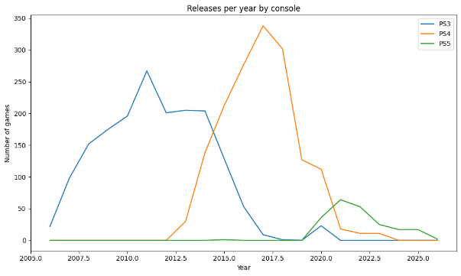 b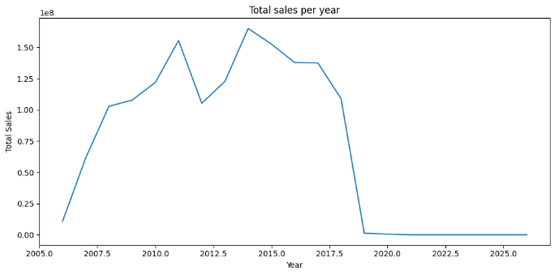
(a) Releases per year; (b) Total sales per year.
a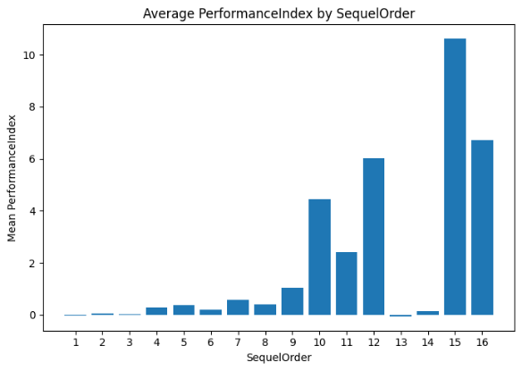b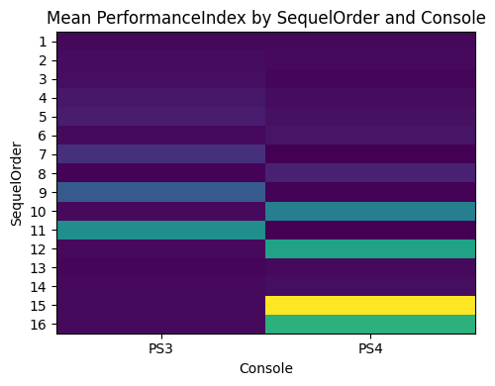
- Average performance index by SequelOrder; (b)Mean performance index by SequelOrder and Console.
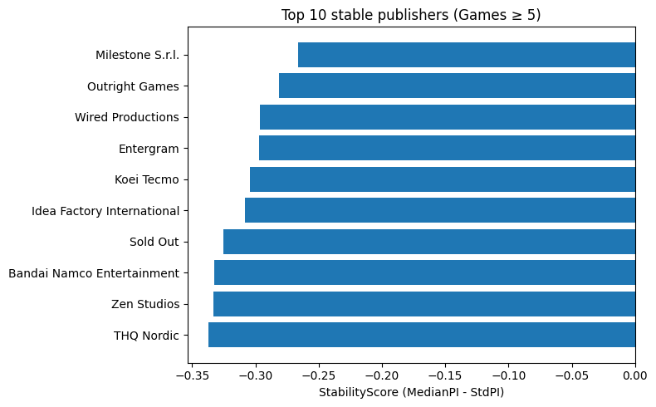
- Top 10 most stable publishers.
References
Clements, M.T. and Ohashi, H., 2005. Indirect network effects and the product cycle: Video games in the US, 1994–2002. Journal of Industrial Economics, 53(4), pp.515–542.

Marchand, A. and Hennig-Thurau, T., 2013. Value creation in the video game industry: Industry economics, consumer benefits, and research opportunities. Journal of Interactive Marketing, 27(3), pp.129–140.

Nair, H., 2007. Intertemporal price discrimination with forward-looking consumers: Application to the US console market. Quantitative Marketing and Economics, 5(3), pp.239–292.

Reimen, T. and Sjoblom, T., 2021. Franchise longevity and sequel performance in digital entertainment markets. Entertainment Computing, 38(1), pp.100–115.

Tschang, F.T., 2007. Balancing the tensions between rationalization and creativity in the video game industry. Organization Science, 18(6), pp.989–1005.

Zhu, F. and Zhang, X., 2010. Impact of online consumer reviews on sales: The moderating role of product and consumer characteristics. Journal of Marketing, 74(2), pp.133–148.

